# Assignment week 4

# Table view and loading JSON Data

## Step 1: Creating the project and the storyboard.

Create a new Single View Application project and give it a good name.

You can safely delete the viewcontroller from the storyboard since we will not use it.

You can also delete the ViewController.h and ViewController.m files.

Now add a TableViewController to the storyboard. Notice how a NavigationController object is created for you as well.

Add a Viewcontroller to the storyboard at the right side of the TableViewController.

Now select the TableViewCell on the TableViewController and ctrl+drag it to the ViewController on the right to create a segue. From the popup menu choose ‘Push’

You’ll end up with something like this:

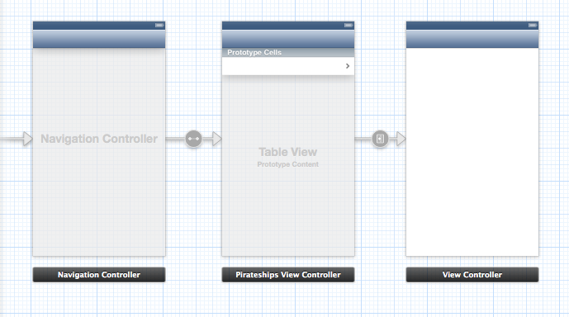

The table view will show a list of pirate names and the viewcontroller will show details about the selected pirate.

Finally select the tableviewCell again and set the identifier to Cell in the attributes inspector tab. 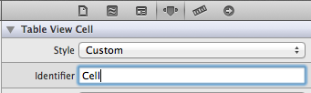

## Step 2: Create the code behind the controllers

Create a new Objetive C class (file -> new file -> Objective C class)

Make it a subsclass of UITableViewController and give it a good name like ‘tableViewController’

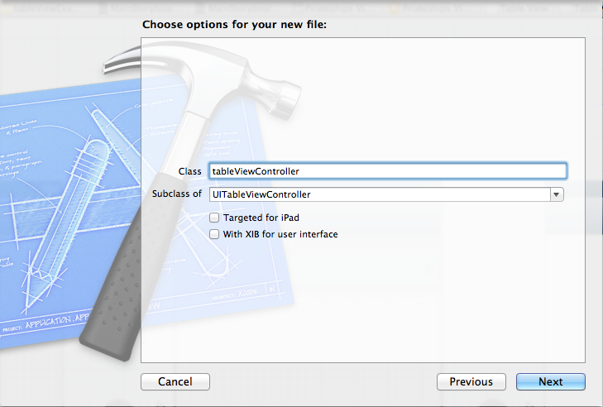

Create another Objective C class. This time make sure it’s a subclass of UIViewcontroller. Give it a good name like ‘detailsViewController’

Select the tableviewcontroller in the storyboard and set the custom class. Do the same for the viewcontroller.

Finally create a new Objective C class that is a subclass of NSObject.

Call it Pirate.

### Step 3: Add AFNetworking to your project.

Read and follow the manual how to add AFNetworking to your project. You will need it to get a list with pirates from the web.

## Step 4: The pirate class

Take a look at this week’s sheets and add the pirate properties to the Pirate.h file.

* name
* Life
* Years active
* Country of origin
* Comments

## Step 5: Initialize the array

Open the tableViewController header file and add a NSMutableArray property to it. Give it a good name like ‘pirates’.

Open the tableViewController implementation file (.m).

Import Afnetworking.h and Pirate.h at the top of the file:

#import "AFNetworking.h"

#import "Pirate.h"

//make sure that you import your detailViewController

#import "DetailViewController.h"

In the ViewDidLoad method create the NSMutableArray.

- (void)viewDidLoad

{

[super viewDidLoad];

// Do any additional setup after loading the view, typically from a nib

self.pirates = [[NSMutableArray alloc] init];

}

## Step 6: Load the JSON data

Take a good look at this week’s sheets. In there you can find a method called ‘loadJsonData. Add it to your tableviewController implementation.

Do the same for the ‘parseJsonData method.

In the parseJsonData method however you must change a few things. **Do not create a NSMutableArray in that method**, but instead use the array property that you created in step 5.

When done parseing, the table should be reloaded.

It should look something like this:

-(void) parseJSONData:(id) JSON

{

//Loop through all objects in JSON array

for (NSDictionary* dict in JSON) {

//Create a pirate object where the json data can be stored

Pirate *pirate = [[Pirate alloc] init];

//Get the JSON data from the dictionary and store it at the Pirate object

pirate.name = [dict objectForKey:@"name"];

pirate.life = [dict objectForKey:@"life"];

pirate.countryOfOrigin = [dict objectForKey:@"country_of_origin"];

pirate.active = [dict objectForKey:@"years_active"];

pirate.comments = [dict objectForKey:@"comments"];

//Add the pirates to the array

[self.pirates addObject:pirate];

}

[self.tableView reloadData];

}

Finally call the loadJsonMethod in the ViewDidLoad method:

- (void)viewDidLoad

{

[super viewDidLoad];

// Do any additional setup after loading the view, typically from a nib

self.pirates = [[NSMutableArray alloc] init];

[self loadJsonData];

}

## Step 7: Show the Pirate Names

In the sheets 3 methods are used to determine the content of the table:

* numberOfSectionsInTableView ,
* numberOfRowsInSection
* cellForRowAtIndexPath

Implement the methods in your tableViewController file in a similar way.

There is 1 section, and at the numberOfRowsInSection method you should return the count of the pirates array instead.

The cellForRowAtIndexPath should like like this:

- (UITableViewCell *)tableView:(UITableView *)tableView cellForRowAtIndexPath:(NSIndexPath *)indexPath

{

//Get the cell. Note that this name is the same as in the storyboard

static NSString *CellIdentifier = @"Cell";

UITableViewCell *cell = [tableView dequeueReusableCellWithIdentifier:CellIdentifier forIndexPath:indexPath];

//Set the correct name in the cell.

//Do so by looking up the row in indexpath and choosing the same element in the array

NSInteger currentRow = indexPath.row;

Pirate * currentPirate = [self.pirates objectAtIndex:currentRow];

NSString *textForCell = currentPirate.name;

//Set the text in the cell

cell.textLabel.text = textForCell;

return cell;

}

## Step 8: Run the application

It should now look like this:

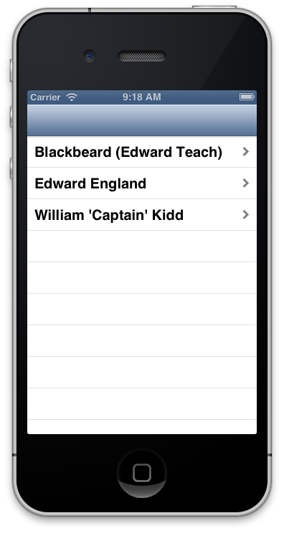

## Step 9: Show the details

Open the detailViewController in the storyboard and add the following UI elements:

5 labels on the left side, and 4 labels and a textviewon the right side.

The left side labels should read:

- Name

- Life

- Active years

- Country of birth.

- Comments

The right labels and the textView should display some text later on, so make sure that you create an IBOutlet to the controller code. Choose some good names.

## Step 10: Which details?

In the detailViewController.h add a property to store a Pirate object.

#import <UIKit/UIKit.h>

#import "Pirate.h"

@interface ViewController : UIViewController

@property Pirate *selectedPirate;

@end

## Step 10: Set the details.

Add and finish the following method to the detailViewController.m:

-(void) viewDidAppear:(BOOL)animated

{

self.nameLabel.text = self.selectedPirate.name;

//Todo set the other UI elements

}

## Step 11: Fix the Segui

Open the tableViewController.m and add the following code:

- (void)prepareForSegue:(UIStoryboardSegue *)segue sender:(id)sender{

//Find the selected pirate

NSIndexPath *selectedRow = [self.tableView indexPathForSelectedRow];

Pirate *selectedPirate = [self.pirates objectAtIndex:selectedRow.row];

//Pass the selected pirate to the next viewcontroller

DetailViewController *controller = segue.destinationViewController;

controller.selectedPirate = selectedPirate;

}